NDG_Forensicsv2_Lab_07 - Data

Alex Arnold

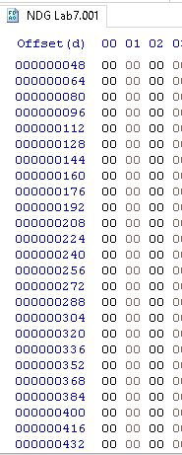

1.9 - Hex view - Offset base

2.13 - opened carved.xlsx file

3.12 - opened carved.pdf file

4.12 - opened carved jpg file

5.19 - tree pane - showing item 4 files